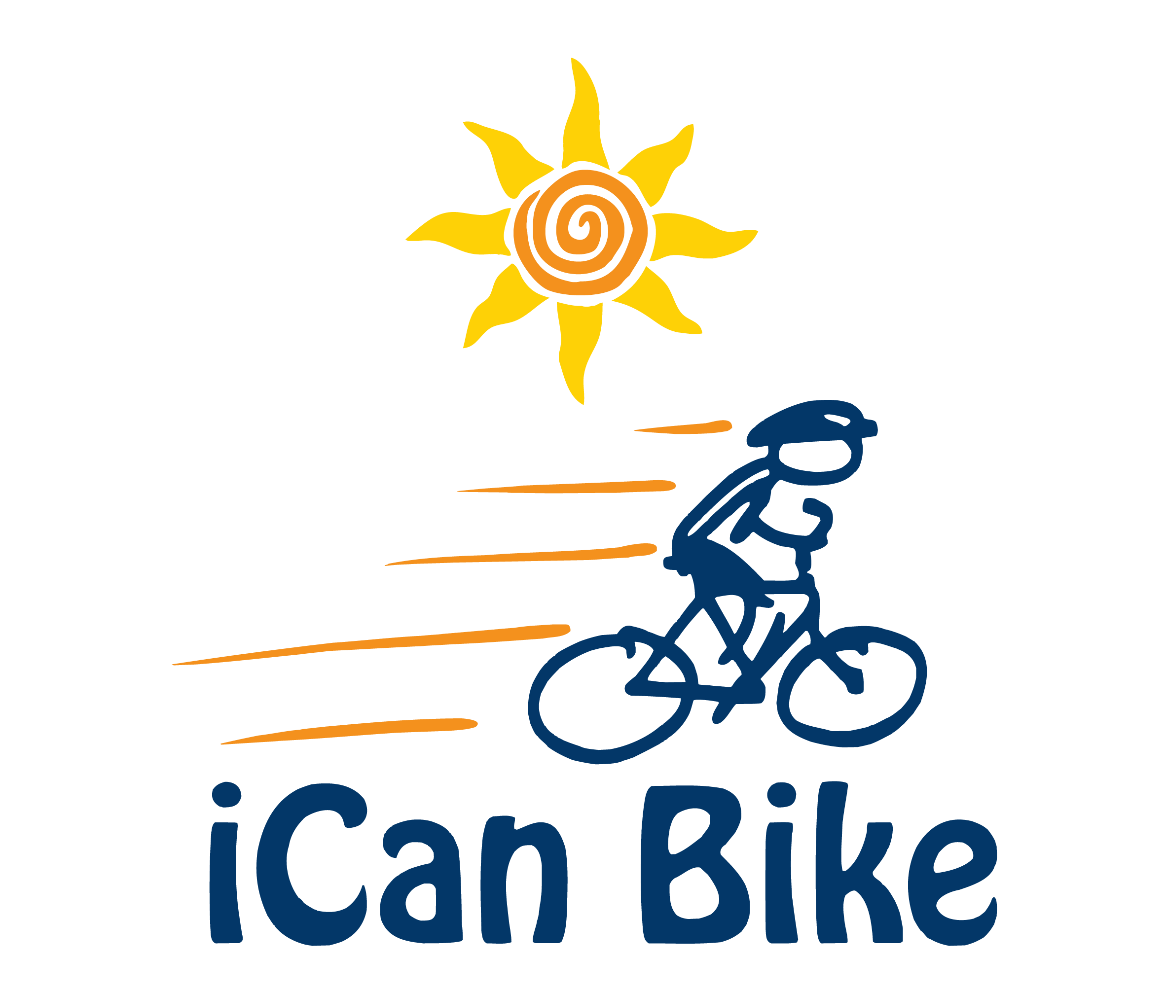

Rider Registration Form

Crimson San Diego 2019 at Alliant University
May 13-17

We are pleased to offer this bike program to people with disabilities and look forward to helping your family member learn to ride a two-wheel bicycle independently.

Requirements for Participation (Rider must meet all of below criteria):

- Minimum age - 8 years old | - Able to sidestep to both sides
- Have a disability | - Able to attend camp all 5 days
- Able to walk without assistive device | - Maximum weight 220 lbs.
- Willing and able to wear a properly  fitted bike helmet | - Minimum inseam of 20” (measure from floor while rider is wearing sneakers)

***All fields are required. Registration will not be accepted if this form is incomplete.***

Rider/Family Information:

Rider First Name:
Rider Last Name:
Rider Gender (M or F):
Rider Date of Birth:
Rider Height (in inches):
Rider Weight:
Rider Inseam (inches from floor while wearing sneakers):
Rider T-Shirt Size:
Parent/Guardian First Name:
Parent/Guardian Last Name:
Parent/Guardian E-Mail:
Parent/Guardian Phone:
Parent/Guardian Cell Phone:
Home Address:
Emergency Contact Name:
Emergency Contact Phone:

Disability Information:

Primary Diagnosis:
Secondary Diagnosis, if any:

Please provide detailed information regarding the above diagnoses that will help us work with the rider effectively (box will expand if more room is needed):

Health Information:

Rider Food Allergies, if any:

Please explain any health/medical conditions or health concerns and any special instructions (box will expand if more room is needed):

Choose A Session:

Please number each session in order of preference (i.e. 1st, 2nd 3rd). Only mark the sessions you are able to attend:
Session #1: 8:00 am – 9:15 am
Session #2: 9:35 am – 10:50 am
Session #3: 11:10 am – 12:25pm
Session #4: 1:10 pm – 2:25 pm
Session #5: 2:45 pm – 4:00 pm

This program is scheduled when most schools are still in session, and your child may miss up to 2 hours of school for 5 consecutive days. We can provide a release letter that can be submitted to your child’s school explaining the importance of your child’s participation

For more information about iCan Bike, go to iCanShine.org
For information about Crimson Treatment & Research Center, go to Crimsoncenteroutreach.org

Payment Information:

Payment of the camp fee is required to process the registration form. Please include deposit check of $100 payable to Crimson Treatment & Research Center (CTRC) OR enter credit card information below. Full tuition is $375 and final payment must be received by April 1, 2019.

Name on Credit Card
Credit Card #
Expiration Date
Security Code
Zip Code

Partial Scholarships are available from CTRC upon request:
I would like to apply for a scholarship: ☐

Military Information
Active Military ☐ Inactive Military ☐ Non-Military ☐

NOTE: There is intentionally a page break here to ensure credit card information (above) does not appear on same page as Rider Information (below) that is printed and shared with Volunteer Spotters
Rider Information
(NOTE: All of the following Rider information is disclosed orally and/or in print form to the Rider’s Assigned Volunteers. Please do not include any information below that you do not consent to being disclosed to the Rider's Assigned Volunteers)

This information helps camp staff & volunteer spotters assigned to work directly with the Rider understand and better serve the individual needs of the Rider.

Rider Name:
Nickname, if any:
Age at Time of Camp:
Diagnosis (optional):

Please place an ‘X’ in the box that most appropriately describes the Rider:

Generally speaking, the Rider…. | Yes | Sometimes | No
can communicate his/her needs
when upset, can manage his/her emotions
follows simple directions
cooperates with others
Is comfortable with physical queues/prompts
responds positively to playful banter
benefits from use of pictures to convey meaning
gets frustrated easily
has trouble staying focused
gets upset by visual or audio stimuli (eg. bright lights, loud noise)
gets upset by background noise such as music or talking
Comments/Additional Information (box will expand if more room is needed):

Please answer each of the following questions (boxes will expand if more room needed):
1. What strategies do you use to promote positive behavior and/or discourage negative behavior that will enable us to work safely and successfully with the rider?

2. What are favorite activities, movies, music, hobbies or other interests of the rider?
3. Has rider previously attended an iCan Bike program (formerly Lose The Training Wheels)?
⎕Yes ⎕No If yes list year(s):
Describe outcome:
4. Has he/she ridden with training wheels? (Yes/No) If yes, please provide a brief history.
5. Has rider experienced a bicycling accident? (Yes/No) If yes, please explain.
6. Through participating in this iCan Bike program, what are your expectations for your rider?

Rider Liability Release

Rider Name:

By signing, I hereby expressly acknowledge that bicycling, like many sports such as swimming, golf, soccer, and gymnastics involves movement and physical activity, and that injury or mishap are possibilities in spite of all reasonable safeguards and precautions taken. Further, I hereby expressly acknowledge that photographs and/or videos of the above rider may be taken by parties outside the control of Shine in connection with participating in bike camp. I acknowledge that Shine has limited or no control over such activities of third parties and has no control over any editing and/or use of such photos and/or video footage. As the parent/guardian of the above rider, I accept such risks as reasonable and proper, and agree to hold harmless the officers, principals, staff and volunteers of Crimson Treatment & Research Center, iCan Shine, Inc., and Rainbow Trainers, Inc. should injury or mishap occur in this regard.

I understand that data collected from this program will be used to help the camp operate effectively relative to appropriate progressions, bike sizing and behavior management. I acknowledge that I may be contacted in the future for follow up information pertaining to rider progress, status or for other requests to support the future development and success of the program.

Parent/Guardian Signature:

I give permission for the above rider to be photographed and/or videotaped in print or electronic media by Shine or Crimson Treatment & Research Center or third parties acting on behalf of Shine or Crimson Treatment & Research Center. acknowledge and agree that photographs and videos may be edited and used in whole or in part as desired for the purpose, which may be produced, duplicated, distributed and used for informational, promotional or other public purposes. I understand that photographs and video are not my property and there will be no compensation to me. I understand and authorize the use in writing or otherwise the name or identity of the above rider.

Parent/Guardian Signature:

Submission Instructions:

Please mail this completed registration form with payment to Crimson Treatment & Research Center * 9606 Tierra Grande #102 * San Diego, CA * 92126
or e-mail to karynls2@crimsoncenter.com

